

Code of Conduct for BHRI members

October 2025 - Version 2.0

Purpose of the BHRI
The Brain Health Research Institute (BHRI) aims to connect researchers, the community and stakeholders to do the research that matters. BHRI aims to break down institutional barriers to research collaboration and to fight against the academic system that currently makes researchers compete against each other.

To facilitate our way of working, membership of the BHRI requires acceptance and compliance with this Code of Conduct.

The code is based upon BHRI’s values. These values should be at the heart of everything BHRI members do and inform leadership decision making.

BHRI’s Core Values


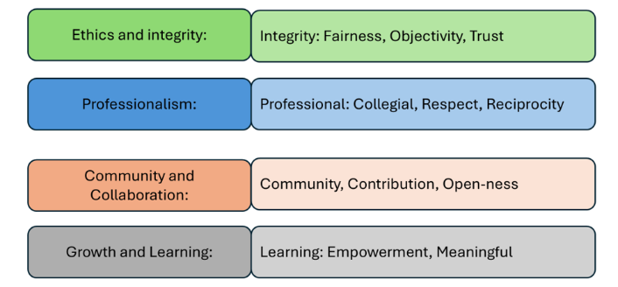

All members are expected to:

- Conduct themselves in a way that enhances the reputation of the BHRI and do not act in such a way to bring the BHRI into disrepute.
- Maintain a collegial and professional approach when working with other members
- Reach out to others members of the team when new research ideas overlap with other members expertise.
- Maintain objectivity and integrity, and work within their scope of practice
- Seek advice from other professionals/experts or the community where necessary
- Respect the cultural and social environment in which they work
- Hold the interests and welfare of people and their whānau as primary importance.
- Present opinions of their own, in a fair, accurate and honest manner
- Only engage with media representing the BHRI following media training

- Remain current with their knowledge of scientific, technical and professional information relevant to the services they offer
- Ensure ethical approvals are obtained from the appropriate bodies where necessary and that research processes are conducted in accordance with ethical approval.
- Declare all potential conflicts of interests that could influence work within the BHRI to the BHRI Director(s) to ensure these are managed correctly.
- Use the BHRI affiliation on work publications arising from work conducted specifically within the BHRI
- Acknowledge the BHRI for contributions made towards research (e.g. through provision of scholarship, research costs) in research publications.

Members should develop, maintain and encourage a high standard of professional training and competence. They accept they are accountable for their own professional actions.

This code will be used by BHRI leadership in determining appropriate courses of action regarding complaints concerning the ethical behaviour of members. This Code covers all BHRI Members while engaged in a professional capacity – whether paid or unpaid.

Members should be familiar with, and are expected to comply with, the requirements of their own country’s legislation

For New Zealand this includes but is not limited to the following legislation and codes:
•Privacy Act 1993This Act outlines the Privacy Principles how "agencies" collect, use, disclose, store and give access to "personal information" www.privacy.org.nz.
•Health and Safety in Employment Act 1992. The purpose of this Act is to promote the prevention of harm to all people at work, and others in, or in the vicinity of, places of work www.osh.govt.nz.
•Health Practitioners Competence Assurance Act 2003. The Acts purpose is to protect the health and safety of members of the public by providing mechanisms to ensure the lifelong competence of health practitioners www.health.govt.nz/our-work/regulation-health-and-disability-system/health-practitioners-competence-assurance-act.
•New Zealand Public Health and Disability Ethics Committees (HDECs). The primary role of the committees is to provide independent ethical review of health and disability research and innovative practice to safeguard the rights, health and wellbeing of consumers and research participants, in particular, those with diminished autonomy www.ethicscommittees.health.govt.nz.

